**Report on the question 6 from Assignment 5  
Computer Vision (CS-559)**

**Name: Dhaval Harish Sharma  
Red ID: 824654344**

**Introduction:**This program takes two images called “Regions.jpg” and “Beans.jpg” as input and produces several output images. The first output image is the simultaneous region detection on the initial image and its respective properties such as centroid, area, etc. The second output image processes the Beans image and gets the edges of the red beans. The third output image processes the same image but gets the minimum distance between red and yellow beans.

**Working of the program:**The program starts by importing the necessary libraries. The regiongrowing is a function for applying the region growing algorithm in order to segment the image. It takes as argument the input image, seed location and the threshold. We first initialize the output image and start iterating through the seeds. We initialize all the necessary variables and iterate through the seed location while going through its four neighbours. If the intensity of the neighbour is close to that of the mean of the region, it is added to the region and all the necessary parameters are updated. This process is continued till there are no neighbours with similar characteristics left. During the same process, we continue to add the indices of the pixels in the region in order to calculate the centroids. The output of this process can be given as follows:

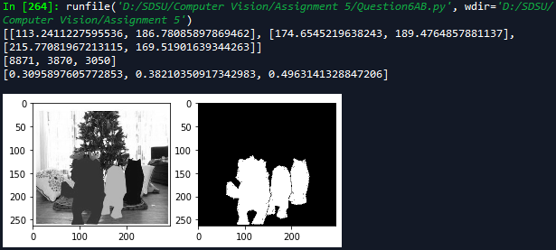

The next program calculates the coordinates of the red beans with the help of its characteristics such as colour and shape. Then, it finds the region using the regiongrowing algorithm with the seed location as found in the previous step. Finally, it finds the edges of the detected region as follows:

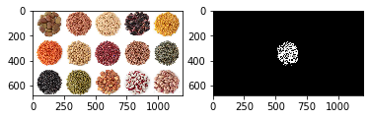

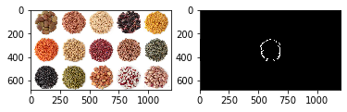

The third and the final program finds the red and yellow beans initially and then calculates the regions of both the beans. Then, it finds the closest points between both the regions and calculates the min distance. The overall detected regions looks as follows:

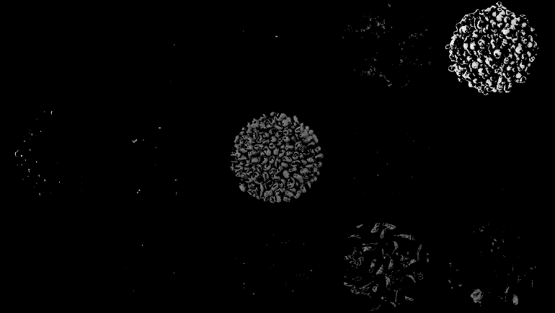

**Findings:**  
The region growing algorithm is a very powerful segmentation technique which can be applied to the image in order to segment it into regions. Only things to consider while applying the region growing algorithm are the seed location and threshold values. It works very well for images which are segmented clearly, meaning that the edges of the elements have a clear difference in the colours. If the image contains edges which are not strong then it may consider them as a same region which will result in a faulty output. The centroid, area and circularity are the important properties of a region as they can help gain a better idea about the elements in the image.

**Conclusion:**Although, the region growing algorithm has some limitations, it is still a powerful technique to segment the image in to regions. It has got several applications in the real world such as robotics, machine learning, etc. It can also be used to get the idea about the various properties of the different objects in the image.